Infopay26/Infopay26Lite V 2.00 Update. Date 02/01/2026

RELEASE NOTES - Please Read Carefully.

Please be aware the National Minimum wage will increase on January 1st 2026.
Full details are available at www.gov.ie/minimumwage

RPNS - Please that note that you will be unable to download RPN’s for 2025 after December 31st 2025

You can find the Auto Enrolment Pension Scheme details here: https://infopay.ie/Help/Auto_Enrolment_Pension_Scheme.pdf

DOWNLOADING Infopay2026:

IF YOU ARE AN INFOPAY USER
Please download the latest version from www.infopay.ie/2026/infopay26install.exe

IF YOU ARE AN INFOPAYLITE USER
Please download the latest version from
www.infopay.ie/2026/infopay26liteinstall.exe

Please note that our website www.infopay.ie is currently being updated. The infopay downloads will also be available on the User Support section of the website (password: childsplay) within the next few days.

AUTO ENROLMENT PENSION SCHEME (AE)

All employers are required to register at www.myfuturefund.ie.

This site is called The Portal. On this site one can download AEPN files and upload Contribution files, which are also called Payroll Files by NEARSA.
We have decided to call them Contribution Files to avoid confusion with Payroll Files in the ROS system.

Infopay is operating a manual and automatic system for AE purposes.

The manual system means that you will have to download an AEPN file from the Portal, import into Infopay, do your payroll as normal and then upload the Contribution file through the Portal.
If you are offered an option to choose between JSON or XML file, always choose XML.
The automatic system connects directly to NEARSA, and allows you to automatically download and import the AEPN files into Infopay, using your ROS certificate. It also allows you to create a Contribution File, view its content and automatically submitted to NEARSA.

This is similar to the PMOD system, which allows you to use ROS or Webservices.
The Portal is the equivalent of ROS, and NEARSA is the equivalent of the Webservices.
The Menu options shown below are available to facilitate this.

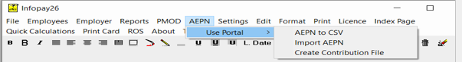
Manual System

Automatic System
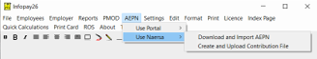

Our Technical Team are working on the upgrading system and hope the update will be available shortly.

